**MENTAL HEALTH THERAPIST:**

**Problem Statement:**

The problem at hand is the limited access to mental health interventions and the reluctance of individuals to seek help due to stigma. To address this, there is a need to develop a scalable and interactive Mental Health Chat bot System. The chat bot will serve as a virtual therapist, providing personalized support, resources, and recommendations. The goal is to bridge the gap in mental health services and empower individuals to proactively manage their mental well-being.

**Goal of the Project:**

The goal of our Mental Health Chat bot android application project is to improve accessibility to mental health support and interventions, particularly for individuals who face barriers in seeking help. We aim to create a user-friendly and scalable solution that addresses the global shortage of mental health professionals and the limited access to services. Through the development of a chat bot, our project seeks to overcome the stigma associated with mental health and provide a confidential platform where users can seek emotional support without fear of judgment. Our goal is to empower users by providing a safe and confidential space where they can openly express their emotions, seek guidance, and receive evidence-based recommendations and resources. We strive to personalize interventions based on the unique needs and emotional states of users, using natural language understanding and sentiment analysis techniques.

**Requirements:**

**Software Requirements:**

¬ Operating System: Windows

¬ Application Development Framework: rasa framework

¬ Programming Language: Java

¬ User Interface Design: XML

¬ Tools: Android Studio

**Hardware Requirements:**

¬ Processor: i3 Processor

¬ RAM: 512 MB

¬ Hard Disk: 40 GB

¬ Internet Connection: Required

**Design**

Designing the Mental Health Chat bot android application involves several key components to ensure its functionality and effectiveness. Here is an overview of the design considerations for the proposed system:

User Interface (UI) Design: The application's UI should be intuitive, visually appealing, and easy to navigate. It should incorporate user-friendly controls, clear instructions, and appropriate visual elements to enhance the user experience. Chat bot

Functionality: The chat bot's design should focus on natural language understanding (NLU) and sentiment analysis. It should be capable of analysing user inputs, interpreting intents, and extracting relevant information to provide appropriate responses and recommendations.

Personalization: The design should enable the chat bot to personalize interventions based on user emotions and interaction patterns. This involves implementing algorithms and techniques to analyse user data and deliver tailored support.

Secure and Confidential Environment: The design should prioritize data security and confidentiality. User information should be encrypted, and appropriate measures should be implemented to ensure the privacy and anonymity of users within the application.

Natural Language Processing (NLP): The design should incorporate NLP techniques to accurately comprehend and interpret user inputs. This includes implementing algorithms for language understanding, entity recognition, sentiment analysis, and context awareness.

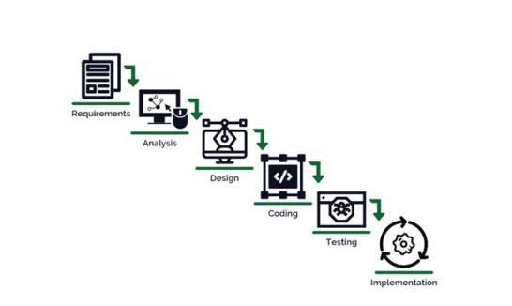

**Basic steps of development**